**RESUME**

**ARPITA BHASKER** 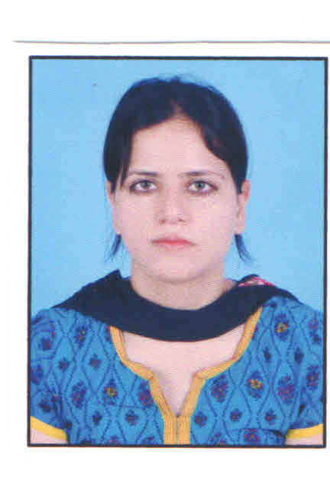

### Email[: arpitabhasker2009@gmail.com](mailto:arpitabhasker2009@gmail.com) Mobile: 8076507318

**Address:** H no. 334, Sector-4, Gurugram, Haryana

**POST APPLYING FOR: PYP, MYP, IB ITGS/Computer Science teacher.**

**CAREER OBJECTIVES**

To become a successful and to work in an innovative and competitive world which will help me to explore myself fully and realize my potential. Willing to work as a key player in challenging & creative environment. I am also confident of my ability to work in a team.

**ACADEMIC QUALIFICATION**



|  |  |  |  |
| --- | --- | --- | --- |
| **COURSE** | **SPECIALIZATION** | **UNIVERSITY** | **Percentage/Division** |
| **BCA** | Computers | From CCS university (RCCV Girls College) | First division |
| **MCA** | Computers | From UP technical University  (ABES Engineering  College) | First division |
| **M A (English)** | English | From Karnataka state  Open university (KSOU) | 70% |
| **Bachelor of Education (2018-2020)** | Education/CS&IT | Chandrawati College of Education, MDU  Rohtak University | 72% |

|  |  |  |  |
| --- | --- | --- | --- |
| **Pursuing CELTA Certiﬁcation program.** | CELTA syllabus and curriculum for teaching English. | Oxford University,  Barcelona, Spain. | NA |

|  |  |  |
| --- | --- | --- |
| **Designation** | **Roles** | **Duration** |
| **IT teacher and lab In-charge in BBS school and college Allahabad.** | Taught IT and CS from grade 6 to 12  Conducted practical classes from grade 1 to 12.  ASL speaker (Assessment of speaking and listening) | Worked from 4 November 2015 to October 2016  Special achievements in school -:  Won Second prize in Presentation competition held in school. |
|  |  | Won award for conducting “snow white and seven dwarfs” play in school. |
|  |  | Conducted teacher computer training program in school for teaching staﬀ of all subjects. |

|  |  |  |
| --- | --- | --- |
|  | Taught IT and ITGS (Information technology in a global society) |  |
| **Taught ICT, IT and ITGS**  **in an IB School in Gurgaon.** | * Grade 12 class teacher. | January 2018 to August 2018  Special Achievements -: |
|  | * Examination coordinator. * Successfully completed IB training program January 2018 to August 2018 | * Prepared all DP documents (Course outline etc.) * Participated in the authorization process of the school. |

**PROJECTS COMPLETED**

* Done a project on railway reservation in BCA
* Made a project on online marketing in MCA 4th semester.
* Made a project in Online shopping(www.shoppingmart.com) for the final semester.

## EXTRA-CURRICULAR ACTIVITIES:

* Won second prize in AD making show in college
* Won Third prize in IT quiz in college.
* Won several certificates in cultural activities in school and college.

## SUBJECTS

### C, C++, Coding, MS- Excel, MS- Word, IT Skills.

* Web designing – html, DHTML, CSS, JavaScript, XML
* Artificial Intelligence, Game Development, Code
* In depth knowledge of mobile networking.

PRIMARY ASSETS

* Extra-ordinary communication skills and presentation skills.
* Positive outlook, Open minded and self-organized approach.
* Appetite and interest to learn continuously.
* Flexibility, hardworking and sincere.
* Creative design, problem-solving
* Self-motivated, ambitious, energetic with an exceptional work ethic and willing to go the extra mile to achieve target.

**PERSONAL PROFILE**

Name : Arpita Gaur

Husband name : Dr. Ankur Gaur

Gender : Female

Marital Status : Married Nationality : Indian

Languages Known: English and Hindi.

**DECLERATION**

I hereby declare that statements made in the true complete and correct to the best of my knowledge and belief.

**PLACE**: Gurugram yours faithfully,

**DATE: 31-December-2020**

**ARPITA GAUR**